First way
For Scanner settings, this is needed on the Local PC first.
- Go here
- Create the Key for the VID and PID like this.
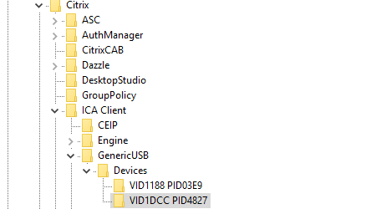
- Inside the Registry Key add a DWORD32 with AutoRedirect 0x0000001 (On the same Client)
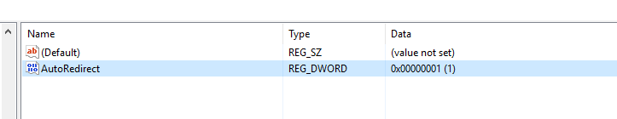

- In Studio, you will need a USB Policy Like this….
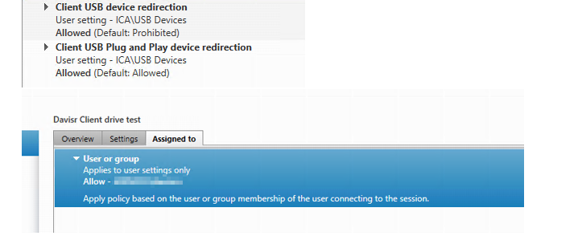

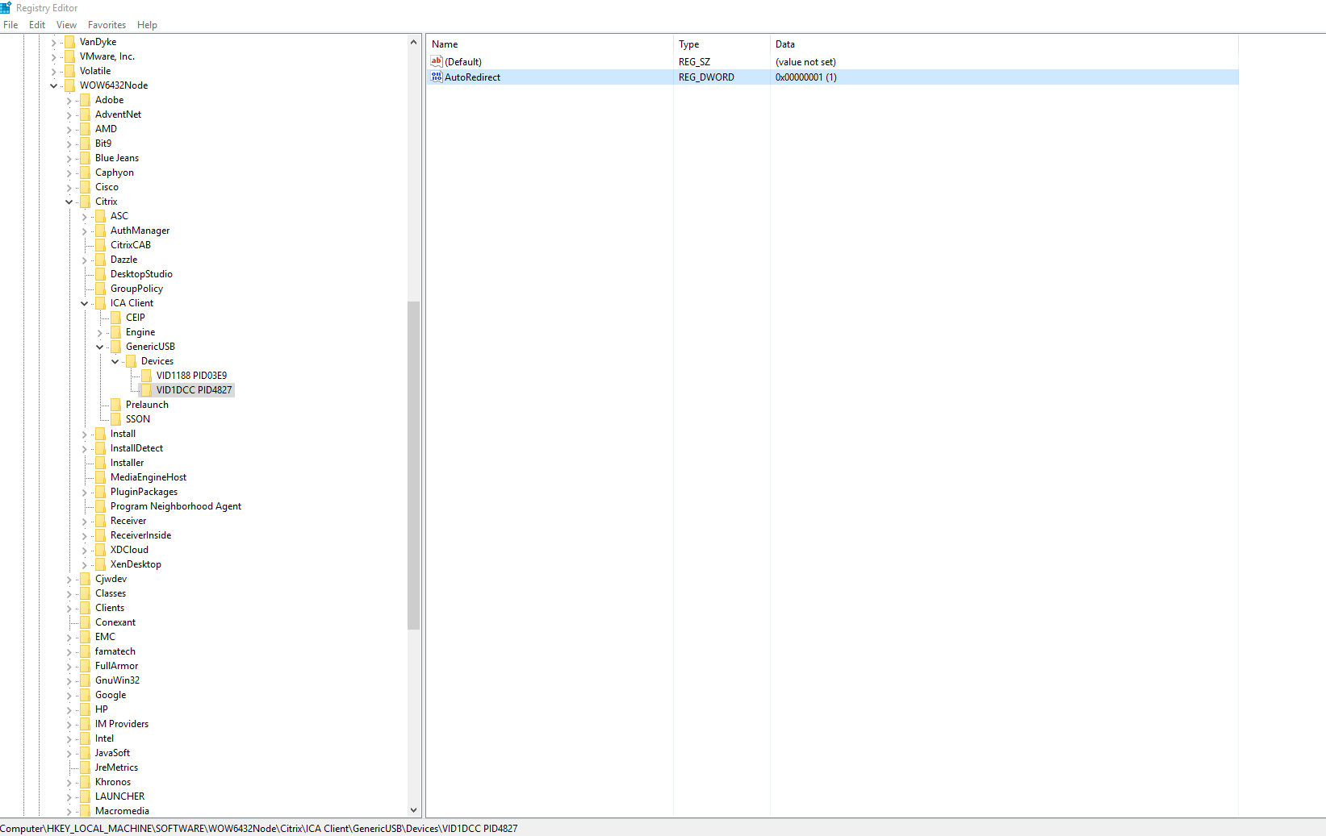

Make sure this is checked.
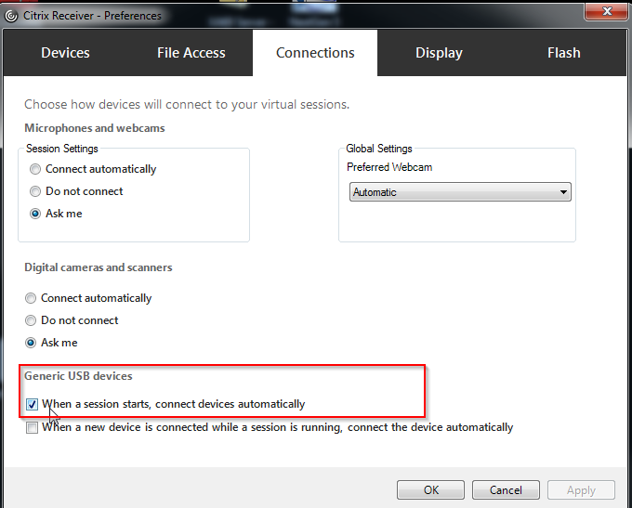

Second way
Citrix Studio Policy
https://support.citrix.com/article/CTX123015
https://docs.citrix.com/en-us/xenapp-and-xendesktop/7-15-ltsr/general-content-redirection/usb.html
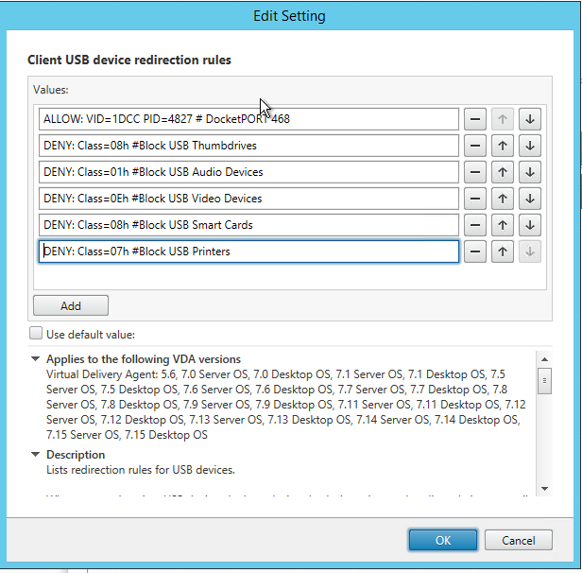
Go here and enable this registry Key (client PC)
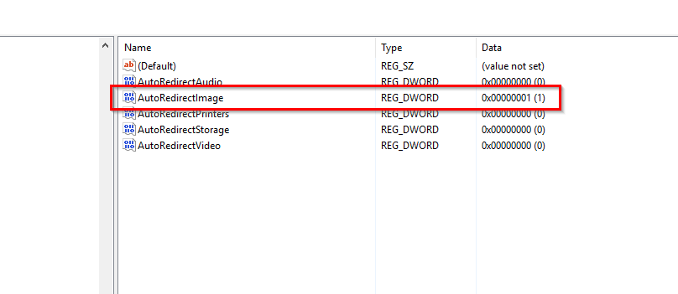

When logging into windows
