- Data source: Single view Result (3 rows with client filter)
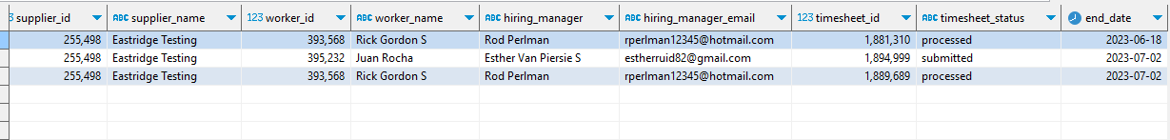

- Same Filters (showing 5 counts, instead of 3 above)
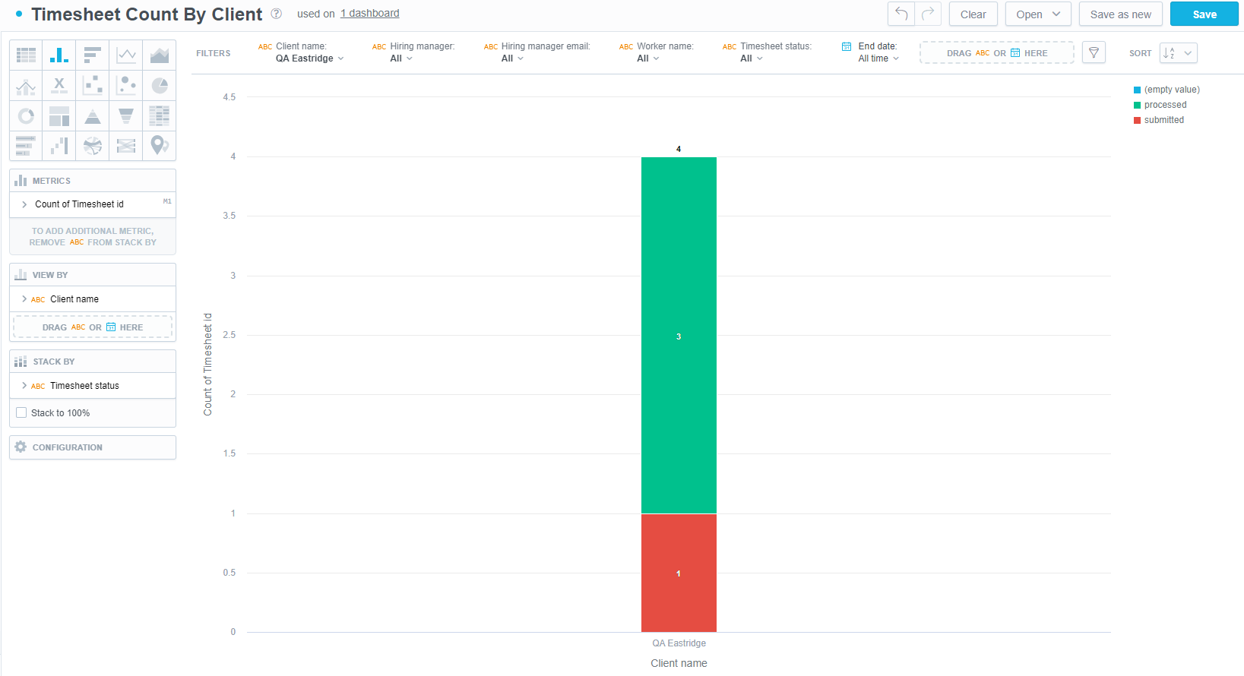

- Same Filters (3 rows with empty values on date fields, this is grouped by day)
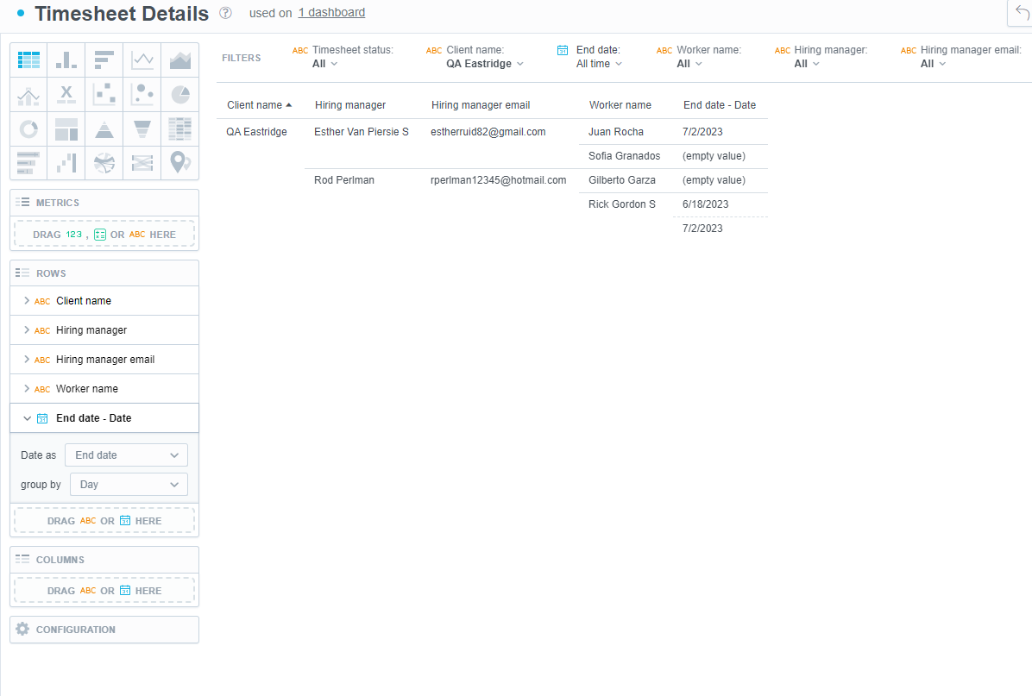

- Same Filters showing correct result when grouped by Hour (Date) (3 rows)
