V2 version of Code:

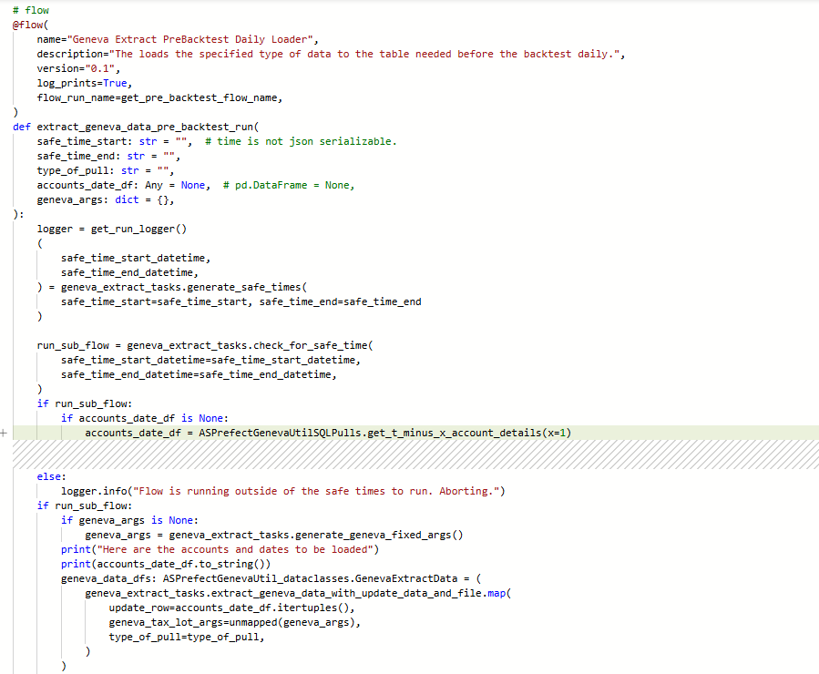
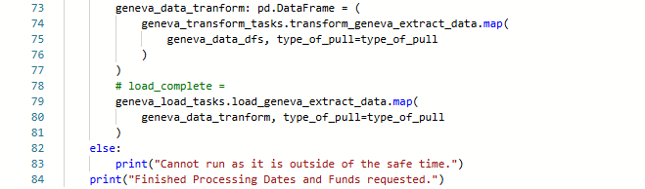

V2 Version of Run:
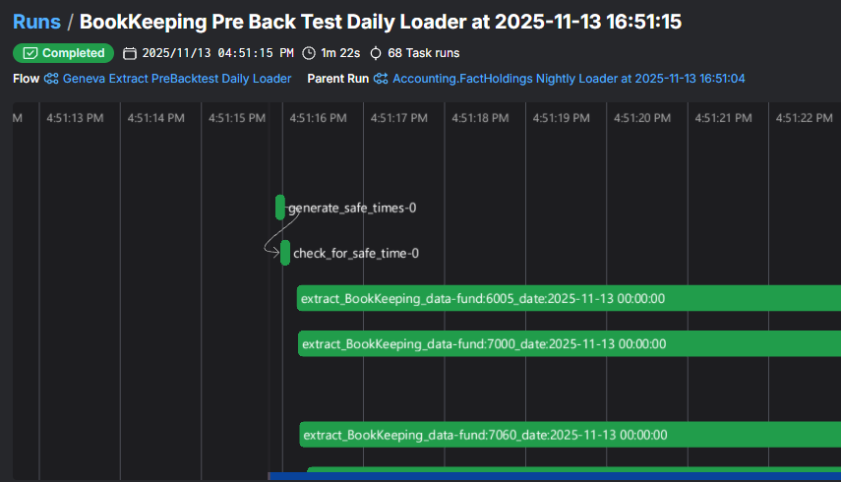

V3 Version of Code:
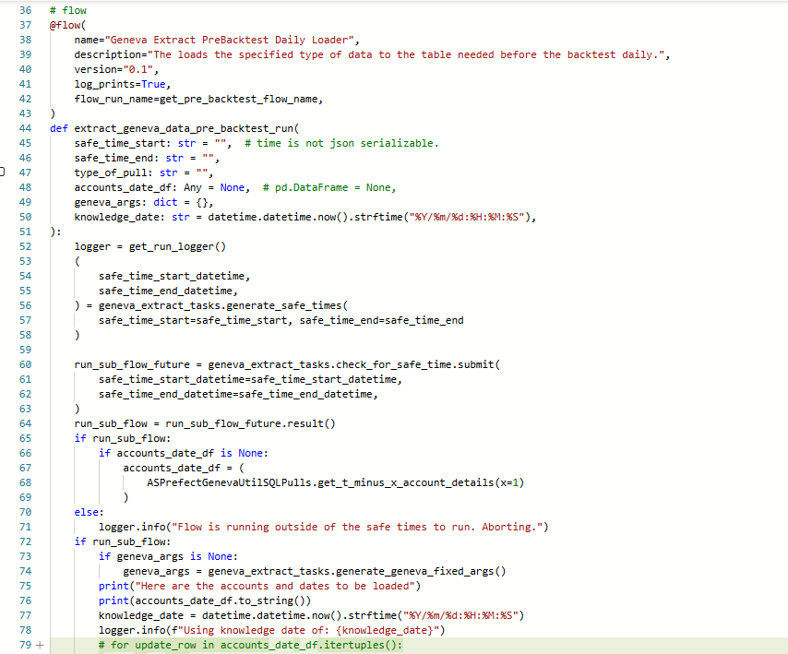
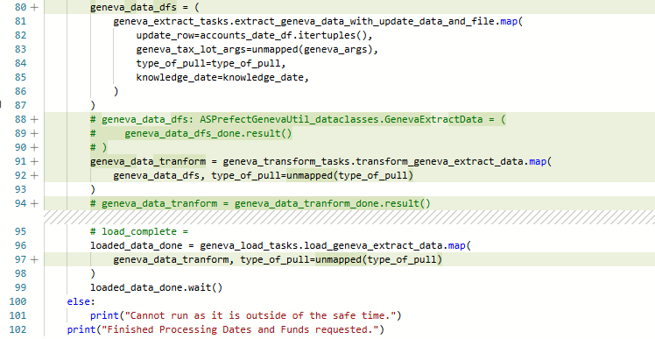
V3 Runtime in production:
Had to get a picture of the parent flow as the child flow wasn’t making a ui flow, this is a hard thing to reproduce, it can take 4 minutes to create the mapped tasks:
